FIG Automation Server

Technical Overview

Author: Imad Ansari
Version: 1.0.0
Last Updated: March 2, 2024
Revision History
Version | Date | Author | Description
1.0.0 - Draft | March 2, 2024 | Imad Ansari | Created Document

Table of Contents
1.0 Overview 1
1.1 System Overview 1
1.1 Interim System 2
1.2 Dependencies 3
1.3 DLL Source Code 4
1.4 Installation Instructions 4
1.5 Usage Example 4
Appendix A – Useful EFS references 1

Overview
This document contains technical information regarding the features, design, installation, and usage of the FIG Automation Server

System Overview

The FIG Automation Server is responsible for the following operations:
- Synchronizing the Price quotes for the active tickers and for the preferred time interval with the server database
- Generating Buy/Sell instructions for the Trading BOT
- Executing orders (e.g. buy, sell, cancel, etc.…) operations with brokerages
- Synchronizing open and closed positions at the brokerages with the server database
- Provide administrative interface to configure the parameters of the automation system and to manually control the flow of operations. Also to view reports and generate notifications

The components of the system are:
- Price Synchronization components.
  - eSignalLink.dll: is a DLL (dynamic link library) that is developed primarily to connect eSignal EFS scripts to external servers through DLL call functions and to provide a simple interface to exchange data using RISC APIs and JSON payload. Price feed coming to eSignal is synchronized into the server database using a custom signal efs script through this link.
  - “Interactive Broker FIG-Service” is a Windows service responsible for retrieving live feed from “Interactive Brokers LLC” and synchronize the server database
  - “Other Providers FIG Service” is future component for a specific Price Provider
- FIG Trading Instruction Service
  - Responsible for Updating ticker prices\
  - Generating instructions for the Trading BOT
- Trading BOT
  - Reads instructions from Server Database
  - Executes orders with the Brokerages.
  - Update database with active opened/closed positions (this may be a separate service)
- FIG Admin Service
  - Responsible for configuring the system
  - Generate reports
  - Alerts and notifications
  - Manual intervention of operations

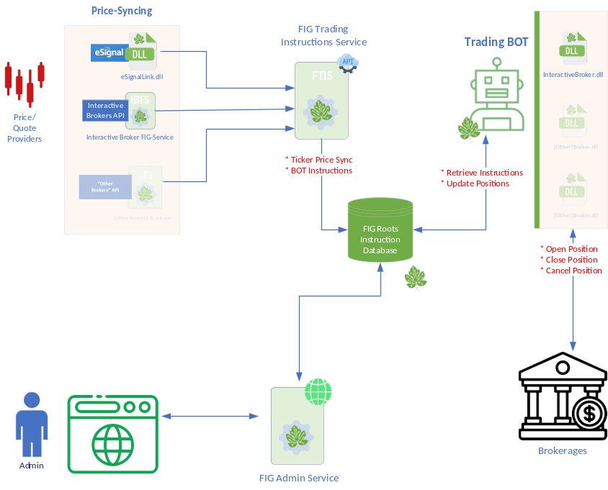

Interim System
In the interim stage, the system is simplified as follows:
- Price synchronization is performed by either the eSignal scripts or through a modified release of the “Interactive Broker LLC” service
- Trading BOT connects directly to Broker and not through a DLL
- The “FIG Trading Instruction” Service and “FIG Admin” Service are combined into one server

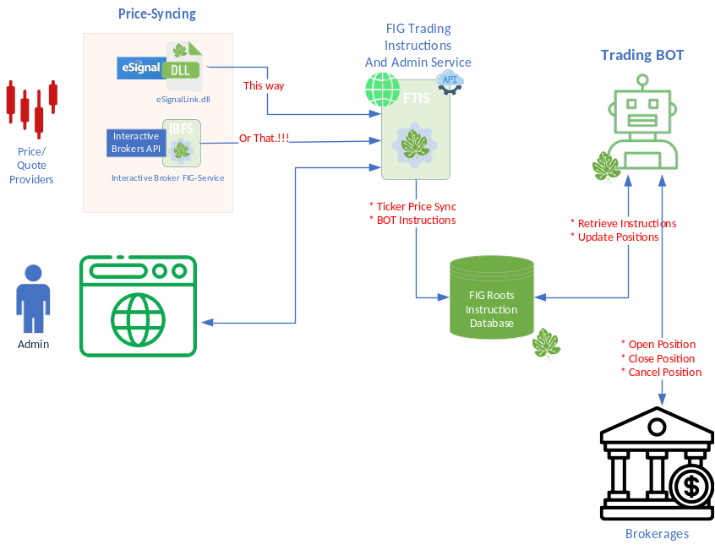

Dependencies
- eSignal Version 12.14 need to be installed (this dll was tested on this particular version, the dll may work on other versions as well) + valid subscription to retrieve prices
- eSignal Formula Script (EFS) scripts
- Microsoft SQL Server Enterprise (64-bit) V15
- ASP.NET Core Runtime 8.0.2
- Active Broker APIs and Subscription
- …
Technical Overview

DLL Source Code
- DLL Name: eSignalLink.dll (Win32 platform) and eSignalLinkx64.dll
Note: the naming convention is intentional so that eSignal can load the DLL properly depending on the installed eSignal version is 32-bit or 64-bit release
- eSignalLink.dll is developed in C++ using Visual Studios 2019
- The code is in GitHub (private repository)
https://github.com/FIGRoots/eSignalLink.git
- Third-party packages used:
  - libCurl
  - openSSL

Installation Instructions
- Copy DLLs (eSignalLink.dll and eSignalLinkx64.dll) to:
"%USERPROFILE%\Documents\Interactive Data\Formulas\My Formulas"
Note that on x64 CPU (64 bit windows) the dll should be compiled for x64 CPU type and the name should end with x64 (eSignalLinkx64.dll)
- Setup the LogPath for the DLL to output diagnostic information to log file and setup Broker communication parameters
  - Open Registry (regedit)
  - Goto the path (create it if not yet there)
HKEY_LOCAL_MACHINE\Software\FIGRoots\eSignalLink
  - Enter Broker’s URL and port
    - BaseURL=http://127.0.0.1 url that the Broker is listening to
    - PortNo=10500 port no (http://127.0.0.1:10500) to
    - LogPath= C:\FIGRoot\LogFiles log file path
- The custom efs that uses the DLL is stored at the same location as the DLL
"%USERPROFILE%\Documents\Interactive Data\Formulas\My Formulas\customstudy.efs"

Usage Example
The following script can be saved as efs script, say test.efs and saved at the custom scripts (My Formulas) of eSignal at:
"%USERPROFILE%\Documents\Interactive Data\Formulas\My Formulas\test.efs"

Then it can be used as a study to test the output

test.efs
var dll = new DLL("eSignalLink.dll");
/**
* This function is called only once, before any of the bars are loaded.
* Place any study or EFS configuration commands here.
*/
function preMain() {
debugClear();
setPriceStudy(true);
setStudyTitle("Example Script");
setCursorLabelName("EMA", 0);
setDefaultBarFgColor(Color.blue, 0);
setShowTitleParameters(true);
//
// Load DLL Functions
dll.addFunction("Add", DLL.INT, DLL.CDECL, "Add", DLL.INT, DLL.INT);
dll.addFunction("Initialize", DLL.INT, DLL.CDECL, "Init");
dll.addFunction("Send", DLL.INT, DLL.CDECL, "Send", DLL.STRING);
// test
var total = dll.call("Add", 1, 1);
debugPrintln(total);
var result = dll.call("Initialize");
debugPrintln(result);
}
/**
* This function is called once per bar on all previous bars, once per
* each incoming completed bar, and if you don't have 'setComputeOnClose(true)'
* in your preMain(), it is also called on every tick.
*/
function main( /*Param1, Param2, Param3, Param4*/ ) {
var jsnObj = {
x1: low(0),
x2: low(-1),
x3: low(-2)
};
debugPrintln(JSON.stringify(jsnObj));
var result = dll.call("Send", JSON.stringify(jsnObj));
debugPrintln(result);
return null;
}

Appendix A – Useful EFS references

DLL Object | Previous Top Next
DLL Object
The eSignal EFS DLL Object allows you to interact with DLL files from within your EFS scripts.
DLL Methods
addFunction() | add an exported function
call() | call an exported function

Notes:
eSignal version 10.6 or earlier:
File location
To simplify the DLL load, place the DLL into \Program Files\eSignal. Then when loading the DLL, just use DLL Name w/o a path.
var d = new DLL("FileName.dll")
It will look into the 'current' (ie Program Files\eSignal) first.
eSignal version 11.0 or later:
File location
The DLL files must be located in either:
1. The same folder as the EFS or in the MyDocuments\Interactive Data\FunctionLibrary folder
In this case it is not required to define a path in the DLL call. The EFS engine will first search the folder containing the EFS and if no DLL is found it will search the FunctionLibrary folder.
2. A sub-folder of the folder containing the EFS or a sub-folder of the FunctionLibrary folder.
In this case a path is required in the DLL call. The path must be relative to the folder containing the EFS or to the FunctionLibrary folder.
Absolute paths are not allowed.
DLLs cannot be called if they are located outside of the Formulas or FunctionLibrary root folders, so any path that specifies a location outside of these folders will cause an error eg
var myVar = new DLL(“../myDLL.dll”); // generates an error
Specifying a relative path using parent references '../' is not recommended, it can be denied in future releases.
var myVar = new DLL(“myFolder/../myDLL.dll”); // not recommended
64bit and 32bit
1. For the 64bit application the file needs to be a 64bit dll. The file name must have the characters x64 appended to it for example myDLLx64.dll
In the DLL() call the x64 suffix used in the file name must be omitted eg
var myVar = new DLL(“myDLL.dll”);
The formula engine will sense the 64bit environment and will automatically append the x64 suffix to the DLL call.
2. For the 32bit application the file needs to be a 32bit dll. No special file naming is required
This arrangement allows developers to include DLL files for both environments without the need to provide separate formulas
DLL.addFunction( refName, returnType, functionDefType, functionName [, parameters...] )
refName | text string to identify the function in EFS
returnType | the type of value that the DLL function returns. must be one of the following:  DLL.DOUBLE  DLL.INT  DLL.SHORT  DLL.FLOAT  DLL.STRING
functionDefType | the calling convention of the exported DLL function. must be one of the following:  DLL.CDECL  DLL.STDCALL
functionName | the name of the DLL function being called
parameters | the input parameters required by the exported DLL function, if any. the following parameter types are supported:  DLL.BYTE  DLL.STRING  DLL.SHORT  DLL.INT  DLL.FLOAT  DLL.DOUBLE  DLL.FLOATARRAY  DLL.DOUBLEARRAY

Note:
functionName is the name of the C/C++ function being called. Your compiler may mangle the function name. You will need to reference the MAP file generated by the linker to determine the actual name. In some cases the compiler prepends the function name with an underscore "_". In other cases the compiler mangles the function name.
DLLs must be plain C DLLs. They do NOT need to be registered (that is only for ActiveX/COM DLLs). MFC, .NET, etc.. are not supported. If someone surrounds C++ code with an extern "C" like below, no mangling of the names occurs, so the .map or .def file is unnecessary.
extern "C" __declspec(dllexport) int giveMe50() {
return 50;
}
Usage
var d = new DLL( "myTest.DLL");
function preMain() {
d.addFunction("MyCallName", DLL.DOUBLE, DLL.CDECL, "Testing123", DLL.INT, DLL.STRING, DLL.FLOAT, DLL.DOUBLE, DLL.BYTE);
}
DLL.call( refname [, parameters] )
refName | text string used to identify the function
parameters | actual values to pass to the DLL
Usage
var d = new DLL( "myTest.DLL" );
function preMain() {
d.addFunction( "MyCallName", DLL.DOUBLE, DLL.CDECL, "Testing123", DLL.INT, DLL.STRING, DLL.FLOAT, DLL.DOUBLE, DLL.BYTE );
//in the above example:
// "MyCallName" is the internal name we have assigned to the DLL function we are calling
// DLL.DOUBLE is the type of value it returns (e.g., a double-precision number)
// DLL.CDECL is the calling convention used by our DLL
// "Testing123" is the actual function name of the exported DLL function.
// DLL.INT signifies that the first input parameter is an integer
// DLL.STRING signifies that the second input parameter is a string
// DLL.FLOAT signifies that the third input parameter is a float
// DLL.DOUBLE signifies that the fourth input parameter is a double
// DLL.BYTE signifies that the fifth input parameter is a byte
}
function main() {
var retVal;
retVal = d.call( "MyCallName", 123, "hello world", 456.23, 544.0014053, 255 );
}

